Enjoy Staffordshire Tourism & Good Food Awards 2022/23

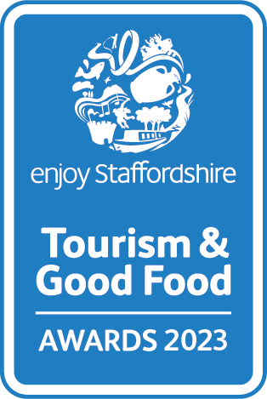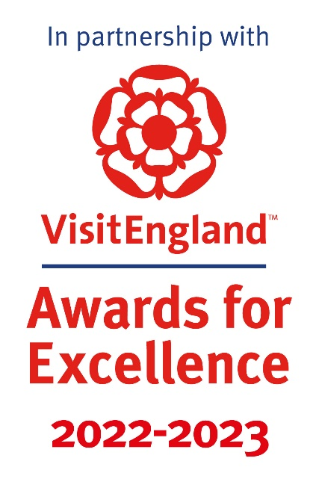

Resilience and Innovation Award
Recognises businesses within the tourism industry that have demonstrated great innovation, resilience and adaptation during a crisis or period of adversity.
Sponsored by We Are Staffordshire
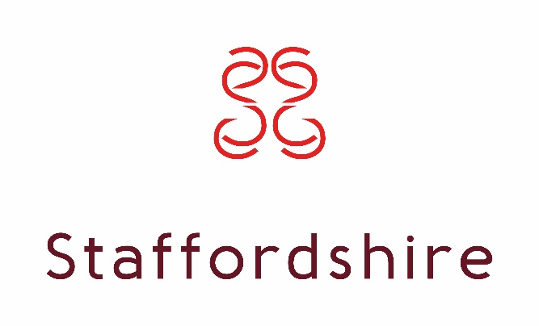
This sample application form is for information only and all applications must be made via the online application system.
https://visitengland-chapters.secure-platform.com/a/organizations/STA/home

Eligibility criteria

• Directly involved in tourism, making a contribution to the visitor economy with a significant proportion of business generated by people visiting from outside the local area
Meets the tourism product definition:
Only tourism businesses who directly serve the end-users are eligible (i.e. the tourist/ visitor/ guest). Business to business agencies or intermediaries e.g. that manage business to consumer (B2C) presence for tourism businesses; would not be eligible
'Tourism product' covers a number of different categories including:
• Accommodation e.g. hotels, bed & breakfasts, guest houses, self-catering/serviced apartments, hostels, holiday boats, camping, caravanning, glamping, lodges, shepherds huts, chalets
• Hospitality i.e. a single food and beverage service business e.g. pub, restaurant, café, tea room, coffee shop, bistros, food and drink markets, kiosks & street food (in a regular location). [For these purposes the definition of a food and drink market is a collection of independent food and drink establishments with ancillary services (e.g. parking area, toilets, security, visitor information) and maintained by a management firm as an entity.]
• Transport services e.g. rail, road, water, airports and rental
• Guided tours
• Cultural services, e.g. theatres, musical entertainment venues, sporting venues
• Travel agencies and other reservation services, including tour operators and destination management companies
• Sporting, adventure and recreational activities
• Retail i.e. a single retail outlet or shopping centre that attracts a significant number of people visiting from outside the local area [For these purposes the definition of a shopping centre is a collection of independent retail stores with ancillary services (e.g. parking area, toilets, security, visitor information) and maintained by a management firm as an entity.]
• Businesses providing supporting services to visitors e.g. visitor information providers, left luggage services
• Visitor attractions that meet the visitor attraction definition: a permanently established excursion destination, a primary purpose of which is to allow access for entertainment, interest, or education and can include places of worship; rather than being primarily a retail outlet or a venue for sporting, theatrical, or film performances. It must be open to the public, with or without prior booking, for published periods each year, and should be capable of attracting day visitors or tourists as well as local residents
• Events and festivals are not eligible to apply to this category due to the likelihood of VisitEngland Awards for Excellence winners not being announced until one or two years after the event took place e.g. an event taking place in 2022 may not be recognised by VisitEngland until 2024; the event may have ceased or declined in quality since then
• Businesses of all sizes can apply as this category is judged within the context and style of the business
• Applications from a chain or group operator must relate to a single site and not multiple sites
• Businesses that have been trading for at least three months and up to two years when applications open are strongly recommended to apply to the New Tourism Business of the Year category before considering applying to any other categories.
• For the purpose of eligibility for this competition, ‘trading’ means serving customers. If the business has not been trading this long, then they will need to wait to apply to the competition in 2023/24.

Applicant & business details
(not scored)
Applicant’s name:
Enter the applicant’s name here.

Applicant’s job title:
Enter the applicant’s job title here.

Applicant’s phone number:
Enter the applicant’s phone number here.

Applicant’s email:
Enter applicant’s email here.

Business name:
Name of business application relates to. Give the name used to promote the business, as you wish it to appear in all publicity materials, on certificates, in presentations etc.:
Enter your business name here.

Business address:
Enter your business address here.

Closures during judging period (the judging period runs from 01/07/2022 – 31/12/2022):
Enter closures during the judging period here.

Promotional Description
Provide a promotional description of your business.
- Focus on its strengths and stand out features
- Write your description with regard to this category
- This wording will be used in PR and awards literature
- Wording provided is subject to edit
- 120 word maximum
Enter the promotional description here.

Promotional Images
Provide up to three landscape high resolution photos.
- Photos should relate to this category
- Photos should not be edited in any way e.g. embedded text or logos, a collage
- Only include photos that you own the copyright for
- If the photo requires a credit e.g. photographer, please provide details
- These photos will be used in PR and awards literature

Background
(not scored)
Briefly outline the story of your business (250 words maximum).
For example:
- Length of time business has been trading and time under current ownership
- Target market(s) and typical customer profile
- Key milestones in developing the business
- Indication of size of business
- Number of staff employed, if any
Enter information on the background of your business here.

List any awards, ratings, accolades and COVID-19 reassurance accreditations received in the last two years. Include the title, awarding body, level and date achieved.
For example:
- Successes in this competition and the VisitEngland Awards for Excellence
- TripAdvisor Certificate of Excellence
- Michelin stars
- Green Tourism award, Staffordshire Environmental Quality Mark
- VisitEngland and/or AA quality assessment, local quality accreditation
- VisitEngland’s ‘We’re Good to Go’; the AA’s ‘COVID-19 Confident’; Quality in Tourism’s ‘Safe clean and legal’
Enter information on any awards, ratings or accolades here.

There is no requirement for your business to be quality assessed. However, if you have an independent quality assessment/mystery shopping report from the last two years, you might wish to attach it when emailing your completed application form /upload it here (optional).

Online presence & reviews
(this section is 30% of the final score)
Provide links to your online presence, which will be reviewed and scored by judges in addition to your answers to the four questions. Other sites may also be checked.
As part of this review, judges will be looking for evidence of your commitment to Accessible and Inclusive Tourism and Ethical, Responsible and Sustainable Tourism, in addition to COVID-19 customer reassurance.
Website (10%)
Enter the website URL here.

Accessibility & inclusivity information (Provide links to your accessibility and inclusivity information.)
Enter the accessibility & inclusivity information URL here.

Sustainability information (Provide links to your sustainability information.)
Enter the sustainability information URL here.

Social Media Platforms (10%)
Provide links to all business pages/profiles on Facebook, Instagram etc. and Twitter handles
Enter social media platforms here.

Online review sites (10%)
Provide specific links to customer review listings for your business e.g. TripAdvisor, Facebook, Booking.com, Google, Euan’s Guide, UpFront Reviews
Enter online review sites here.

Application
(this question is 70% of the final score)
Tell us why your business deserves to be recognised for the Resilience and Innovation Award (500 words maximum).
We are looking for examples of how your business has demonstrated great innovation, resilience and adaptation during a crisis or period of adversity, e.g. the COVID-19 pandemic, severe weather events. Examples can include one or multiple of the following areas (it is not mandatory to cover every area):
- New or different products, or new markets, including diversification
- Improvement of how you do things, including customer communications
- Development of business strategies, systems and structures, including digital operations (e.g. ticket/ booking, virtual experiences)
- Collaboration initiatives and working beyond boundaries, including tourism industry and community support
- New practices to ensure the longer-term viability of the business
Enter answer to question here.

Links to relevant supporting evidence online (optional):
You will not be penalised if you have not included supplementary evidence. Any written answers that are included within the supplementary evidence, attempting to circumvent the question word counts, will be disregarded.
Enter links to supplementary evidence here.

