Enjoy Staffordshire Tourism & Good Food Awards 2021/22

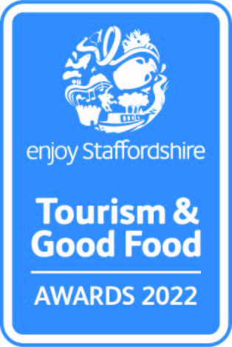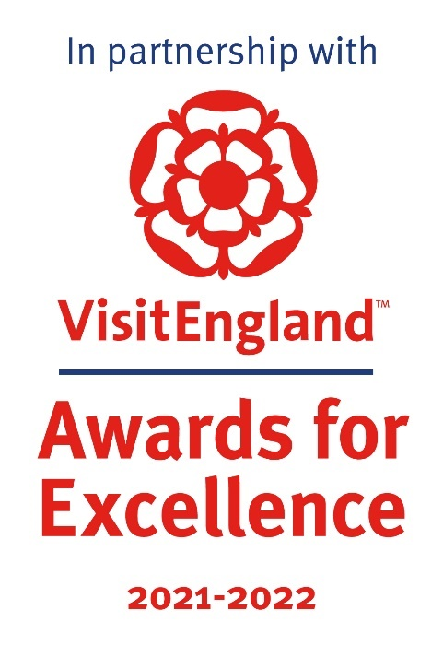

Resilience and Innovation Award
Recognising businesses within the tourism industry who have demonstrated innovation, resilience and adaptation, along with support for their local communities, during the COVID-19 pandemic.
Sponsored by We Are Staffordshire
This sample application form is for information only and all applications must be made via the online application system.
https://visitengland-chapters.secure-platform.com/a/organizations/STA/home

Eligibility criteria

• Directly involved in tourism, making a contribution to the visitor economy with a significant proportion of business generated by people visiting from outside the local area
Meets the tourism product definition:
Only tourism businesses who directly serve the end-users are eligible (i.e. the tourist/ visitor/ guest). Business to business agencies or intermediaries e.g. that manage business to consumer (B2C) presence for tourism businesses; would not be eligible
'Tourism product' covers a number of different categories including:
• Accommodation e.g. hotels, bed & breakfasts, guest houses, self-catering/serviced apartments, hostels, holiday boats, camping, caravanning, glamping, lodges, shepherds huts, chalets
• Hospitality i.e. a single food and beverage service business e.g. pub, restaurant, café, tea room, coffee shop, bistros, food and drink markets, kiosks & street food (in a regular location). [For these purposes the definition of a food and drink market is a collection of independent food and drink establishments with ancillary services (e.g. parking area, toilets, security, visitor information) and maintained by a management firm as an entity.]
• Transport services e.g. rail, road, water, airports and rental
• Guided tours
• Cultural services, e.g. theatres, musical entertainment venues, sporting venues
• Travel agencies and other reservation services, including tour operators and destination management companies
• Sporting, adventure and recreational activities
• Retail i.e. a single retail outlet or shopping centre that attracts a significant number of people visiting from outside the local area [For these purposes the definition of a shopping centre is a collection of independent retail stores with ancillary services (e.g. parking area, toilets, security, visitor information) and maintained by a management firm as an entity.]
• Businesses providing supporting services to visitors e.g. visitor information providers, left luggage services
• Visitor attractions that meet the visitor attraction definition: a permanently established excursion destination, a primary purpose of which is to allow access for entertainment, interest, or education and can include places of worship; rather than being primarily a retail outlet or a venue for sporting, theatrical, or film performances. It must be open to the public, with or without prior booking, for published periods each year, and should be capable of attracting day visitors or tourists as well as local residents
• Events and festivals are not eligible to apply to this category due to the likelihood of VisitEngland Awards for Excellence winners not being announced until one or two years after the event took place e.g. an event taking place in 2020 may not be recognised by VisitEngland until 2022; the event may have ceased or declined in quality since then
• Businesses of all sizes can apply as this category is judged within the context and style of the business
• Applications from a chain or group operator must relate to a single site and not multiple sites

Applicant & business details
(not scored)
Applicant’s name:
Enter the applicant’s name here.

Applicant’s job title:
Enter the applicant’s job title here.

Applicant’s phone number:
Enter the applicant’s phone number here.

Applicant’s email:
Enter applicant’s email here.

Business name:
Name of business application relates to. Give the name used to promote the business, as you wish it to appear in all publicity materials, on certificates, in presentations etc.:
Enter your business name here.

Business address:
Enter your business address here.

Promotional Description
Provide a promotional description of your business.
- Focus on its strengths and stand out features
- Write your description with regard to this category
- This wording will be used in PR and awards literature if you are short listed as a finalist
- Wording provided is subject to edit
- 120 word maximum
Enter the promotional description here.

Promotional Images
Provide up to three landscape high resolution photos.
- Photos should relate to this category
- Photos should not be edited in any way e.g. embedded text or logos, a collage
- Only include photos that you own the copyright for
- If the photo requires a third-party credit e.g. photographer, please provide details
- These photos will be used in PR and awards literature if you are short listed as a finalist

Background
(not scored)
Briefly outline the story of your business (250 words maximum).
For example:
- Length of time business has been trading and time under current ownership
- Target market(s) and typical customer profile
- Key milestones in developing the business
- Indication of size of business
- Number of staff employed, if any
Enter information on the background of your business here.

List any awards, ratings, accolades received in the last two years, including any that relate to COVID-19. Include the title, awarding body, level and date achieved.
For example:
- Successes in this competition and the VisitEngland Awards for Excellence
- TripAdvisor Certificate of Excellence
- Michelin stars
- Green Tourism award, Staffordshire Environmental Quality Mark
- VisitEngland and/or AA quality assessment, local quality accreditation
- VisitEngland’s ‘We’re Good to Go’; the AA’s ‘COVID-19 Confident’; Quality in Tourism’s ‘Safe clean and legal’

Enter information on any awards, ratings or accolades here.

There is no requirement for your business to be quality assessed. However, if you have an independent quality assessment/mystery shopping report from the last two years, you might wish to upload it here (optional).

Online presence & reviews
(this section is 30% of the final score)
Provide links to your online presence, which will be reviewed and scored by judges in addition to your answers to the four questions. Judges will also be looking for evidence of customer reassurance within your online presence as a result of the COVID-19 pandemic. Other sites may also be checked.
Website (10%)
Enter the website URL here.

Social Media Platforms (10%)
Provide links to all business pages/profiles on Facebook, Instagram etc. and Twitter handles
Enter social media platforms here.

Online review sites (10%)
Provide specific links to customer review listings for your business e.g. TripAdvisor, Booking.com, Google, Euan’s Guide, UpFront Reviews
Enter online review sites here.

Application
(this is 70% of the final score)
Tell us why your business deserves to be recognised for the Resilience and Innovation Award (500 words maximum).
We are looking for examples of how your business has demonstrated great innovation, resilience and adaptation, along with support for your local community, during the COVID-19 pandemic. Examples can include one or multiple of the following areas (it is not mandatory to cover every area):
- Business diversification
- Virtual experience
- Digital operations (ticketing/ booking etc.)
- Digital PR
- Customer communications
- Collaboration initiatives
- Key worker support
- Tourism industry support
- Community support
Enter your application here.

Links to relevant supporting evidence online (optional):
You will not be penalised if you have not included supplementary evidence. Any written answers that are included within the supplementary evidence, attempting to circumvent the question word counts, will be disregarded.
Enter links to supplementary evidence here.

